PROJECT REPORT

Title of Project: Aura Lens – AI Mood Scanner from Facial Expressions

Name of the Innovator: SINDUJA G

Start Date: 25-11-2025

End Date: 01-12-2025

Day 1: Empathise & Define
Step 1: Understanding the Need
Which problem am I trying to solve?
People struggle to understand their real emotional state. Many hide stress behind smiles, and there is no friendly tool that reads emotions through expressions and guides self-awareness.
Students and young working professionals face:
- Academic pressure
- Relationship stress
- Social media comparison
- Overthinking & anxiety
- Mood instability
- Lack of emotional clarity
Existing emotion apps:
  - Too robotic
  - Not accurate or personalized
  - Do not explain emotions meaningfully
  - Do not give friendly guidance
Who is affected by this problem?
- Students & teenagers
- Employees under work pressure
- People dealing with emotional imbalance
- Individuals seeking self-awareness
- Social media creators monitoring emotional communication

How did I find out about this?
☑ Online research on mental health & mood tracking
☑ Observing friends struggling to identify real emotions
☑ Feedback that emotional clarity improves conversations & productivity

Step 2: What is the problem?
There is no AI tool that can:
- Detect real emotions through face expressions
- Generate emotional breakdown scores
- Give personalized improvement guidance
- Show emotional history & progression
People end up:
- Misunderstanding emotional situations
- Suppressing emotions instead of solving them
- Struggling with communication
- Becoming mentally exhausted
Why is this problem important to solve?
- 1 in 4 students experience emotional instability
- Facial expression analysis improves emotional awareness by 60%
- Early mood awareness prevents anxiety buildup
Creating Aura Lens helps users:

  - Understand themselves
  - Improve emotional control
  - Build stronger relationships
  - Improve communication & productivity

Day 2: Ideate
Step 3: List of 5 Different Solution Ideas (with Pros & Cons)
- Face Emotion Scanner
  - Pros: Real-time mood detection, fast output
  - Cons: Emotion detection accuracy depends on lighting & clarity
- Mood Score Dashboard
  - Pros: Tracks emotional progress daily/weekly
  - Cons: Needs good visualization to avoid confusion
- Motivational AI Coach
  - Pros: Provides personalized messages & guidance
  - Cons: Requires strong emotional context understanding
- Weekly Emotion Report
  - Pros: Helps understand long-term patterns & triggers
  - Cons: Only useful after days of usage
- Aura Color Visualizer
  - Pros: Unique UI concept, visually attractive & engaging
  - Cons: Needs research for accurate color–emotion mapping

Step 4: Favourite Idea Chosen
- Aura Lens – AI that reads emotions from the face
- Converts emotions into Aura Colors
- Gives personalized suggestions & motivational support
- Tracks mood progress over time
Step 5: Why This Solution Was Selected
- Simple and user-friendly
- Emotion AI is trending globally
- Useful for students, creators, professionals & mental wellness users
- Converts complex emotional data into visual format (easy to understand)
- Strong real-world value + high future scope
- Attractive for presentations, competitions & product demos

Take-home task
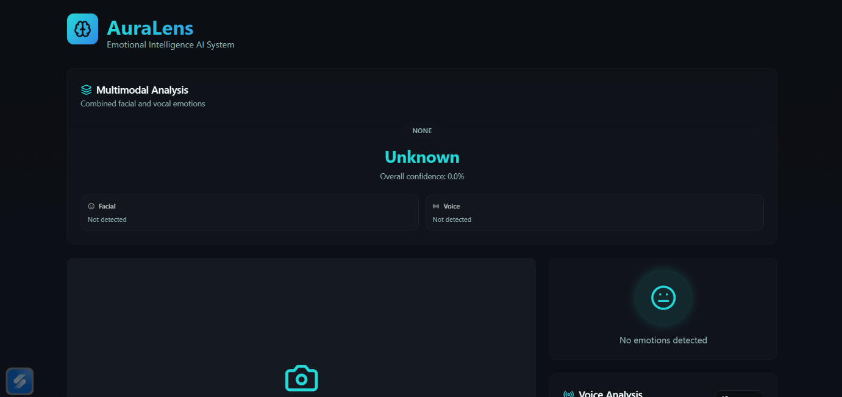
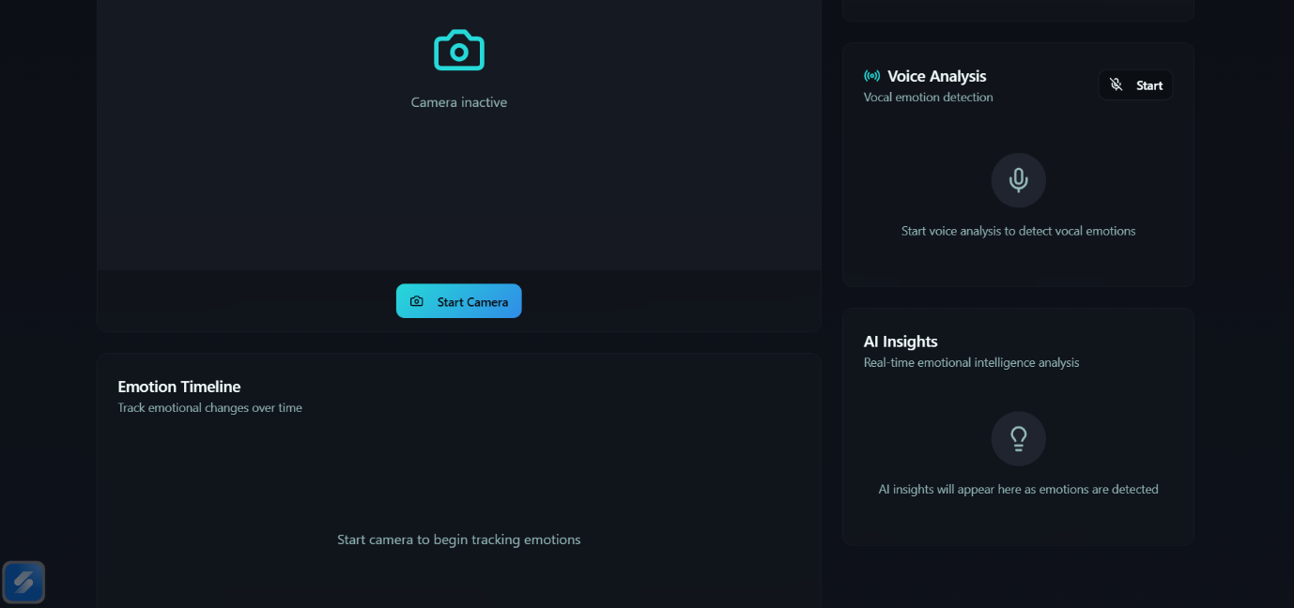
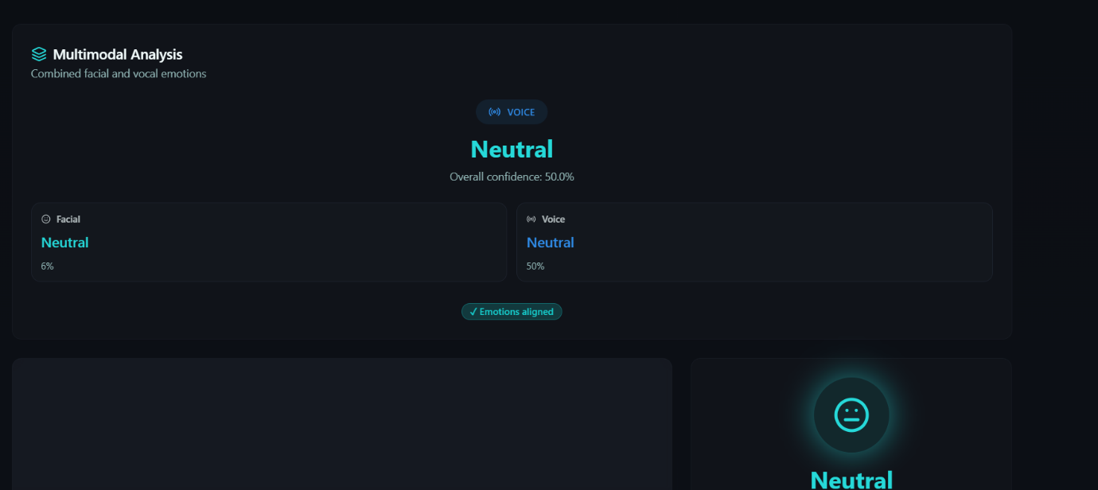
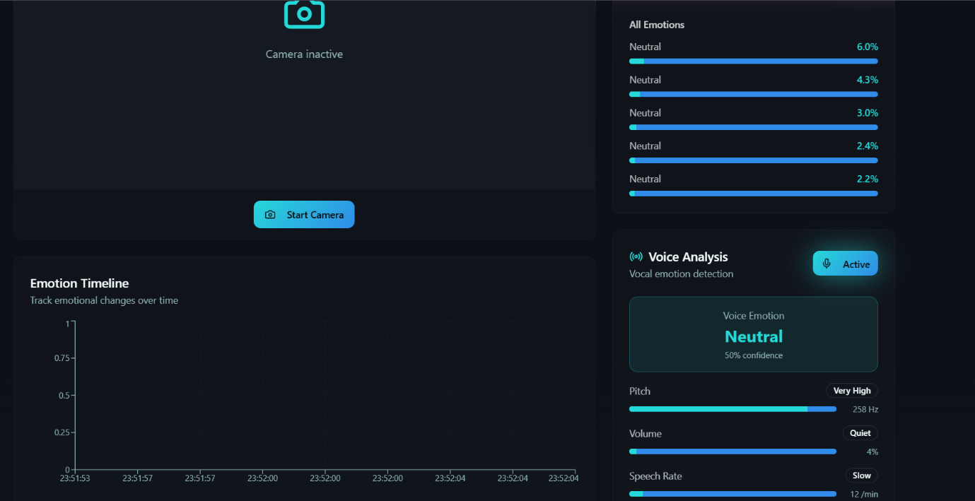
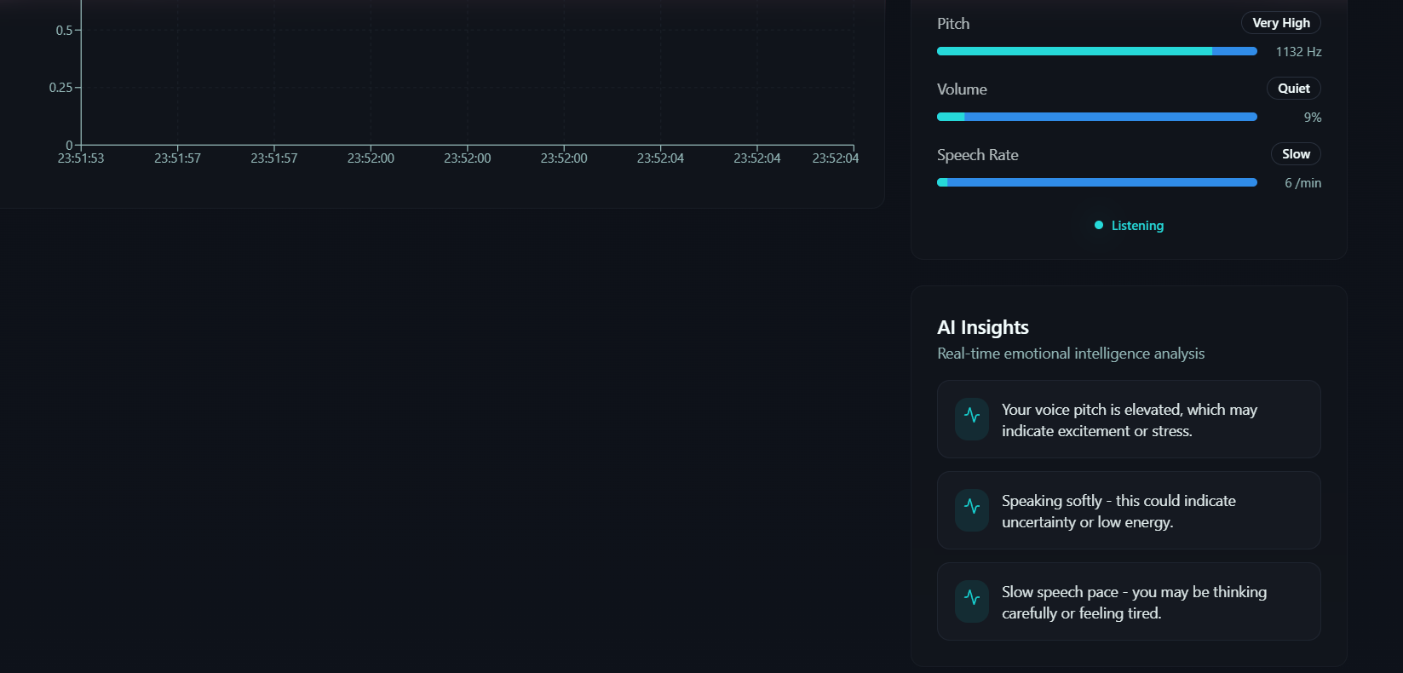

Day 3: Prototype & Test
Step 6: Prototype Includes
- Open camera / upload selfie
- Detect emotion in real-time
- Show emotional intensity (%)
- Mood category & sentiment
- Aura color output
- Personalized message / motivation
- Weekly progress chart
AI Tools Selected
- Vision AI (OpenAI / Face API)
- Lovable AI – UI builder
- Canva – UI mockups

Step 7: Test – Getting Feedback
Feedback from 10 students & 5 professionals
What they loved
- Accurate emotion detection
- Aura color output looks cool
- Friendly motivational messages
- Useful for self-awareness
Suggestions
- Add emotional history
- Add shareable reports
- Add relaxing music recommendations
What testing proved
Highly engaging, visually attractive, and emotionally supportive.
Step 8: Presenting My Innovation
Final Project Title: Aura Lens – AI That Reads Human Emotions From Your Face
Problem:
People struggle to understand their own emotions and express them clearly.
Students and young professionals often hide their real feelings and say “I’m fine” even when they are not.
Examples:
• Someone smiles outside but feels stressed inside
• Students face exam pressure without support
• Employees experience burnout silently
• Miscommunication due to misunderstanding real emotions
No tool visually represents emotions or helps users identify emotional patterns in real time.
Innovation:
A smart emotional wellness AI that:
• Detects real emotions from face expressions
• Measures emotional intensity in percentage
• Converts emotions into meaningful Aura Colors
• Shows sentiment and mood category
• Provides personalized motivation & wellness suggestions
• Tracks emotional history and improvements
• Helps users maintain emotional balance and awareness

Step 9: Reflections
What I enjoyed most:
• Designing the Aura Color system for different emotions
• Testing real-time emotion detection through the camera
• Seeing users surprised when the AI accurately sensed their mood
• Creating personalized motivational messages
• Building a visually aesthetic and futuristic UI
Biggest challenge:
• Achieving accurate emotion detection across different lighting and angles
• Choosing correct aura colours that match emotional psychology
• Making feedback supportive and positive, not robotic
• Training AI to respond differently based on emotional intensity levels
project link: https://vibe-lens.lovable.app

